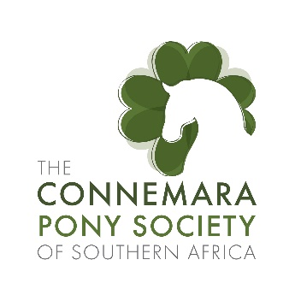
Sport Performance Awards 2018.
Awarded for SANESA achievements 2018

For the first time, as a committee, we have decided to reward the performance of ponies for their achievements in the various disciplines. This year, SANESA riders are the first to receive of these new awards. We are hoping to soon carry this through to all the SAEF disciplines.
SANESA has kindly provided us with the results of all the Connemara Ponies registered on their system. This includes registered, unregistered, confirmed, and unconfirmed ponies.
In total there are 15 ponies on the SANESA system, 5 are registered with the Connemara pony Society, 2 are confirmed but not registered, and the other 8 are neither confirmed, nor registered with the society.
These ponies range from under 9 off lead dressage, Ashgar Fantasia & Zara Papalardo to endurance, Ashgar Gaiety’s Grace & Monize Meyer (placing 1, 2, 3 in her 3 qualifiers) Ashgar Frederic & Ciara Van Rensburg competing in Show Jumping. The results for the top three ponies is truly remarkable.
Winning this year award is Kilshane Moyne and Pippa Squair (Primary School) competed in 36 qualifiers!! Placed 1st place in 19 of these, 2nd eight times, 3rd x twice, 4th x 6times!! In 8 final selection classes, they finished 1st x 5 times, and 2nd x 1, and in all their other classes in the top 8. In the ten classes they competed in at Nationals they finished in the top 7 places; 3 of these 1st places. Most of these achievements are in level 6 and 7. Competing in dressage, equitation, show jumping, working hunter, working riding, eventing, Handy Hunter and stadium eventing. These are truly fantastic results.
Second place with similar fantastic results is Thomas Van Rijckevorsel & Kilshane Bluebell. This team competed in 59 classes, including 9 finals, and 9 National Championship classes. They achieved 15 x 1st places, 11 x 2nd places, 3 x 3rd places, 1 x 4th, 2x 5th, 1 x 6th and 1x 8th. At finals he had 3x 1st places, 1 x 2nd and the most of the other classes all within the top 7. Nationals 2 x 1st places, and well placed in their other classes. These are remarkable scores, noteworthy is Working Riding and Handy Hunter, in all the qualifiers, Final selection and National Championships they finished first!! For this they received a Special Commendation award.
In third this year is Dibbyn Petticoat Lane & Alexis Human (Connemara x Welsh) competed in 15 qualifiers, placing in the top 3 in 14 of these. (Working riding, Show Jumping, Equitation and Working hunter).
As a result of the top two ponies, the Sud of the Year 2018 is Kilshane Stud.
Congratulations all the Connemara Ponies, holding our flag high. And best wished for 2019.

